Grade 7 Accelerated · Unit 3 · Lesson 3  Exponential Expressions  Independent Set 3.03 | Name______________________  Date______________________  Period____________________

Six questions, on your own, in silence. Show the step that does the work.
1. Find the value. 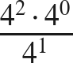

2. Find the value. 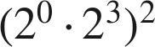

3. Write as one power. 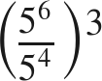

4. Find the value. 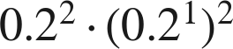

5. Find the value. 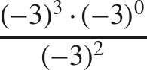

6. Show that 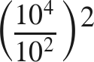 and 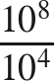 have the same value.

